SET 2: CUSTOMER FEEDBACK ANALYSIS
Dataset: Customer Satisfaction
Department | AIDS
Course Code / Course Name | DSA0601 / Data Handling and Visualization
Experiment | Data Visualization using R
Name | B. Pallavi
Register Number | 192424243
Date | 29 September 2026
Day | Tuesday

Dataset: Customer Satisfaction
Customer ID | Age | Satisfaction Score
1 | 25 | 4
2 | 30 | 5
3 | 35 | 3
4 | 28 | 4
5 | 40 | 5

PROGRAM 1: Histogram of Customer Ages
Create a histogram to represent the distribution of customer ages. Label the axes and title the chart.
# Dataset
age <- c(25, 30, 35, 28, 40)
# Histogram
hist(age,
main = "Distribution of Customer Ages",
xlab = "Age",
ylab = "Frequency",
col = "skyblue")
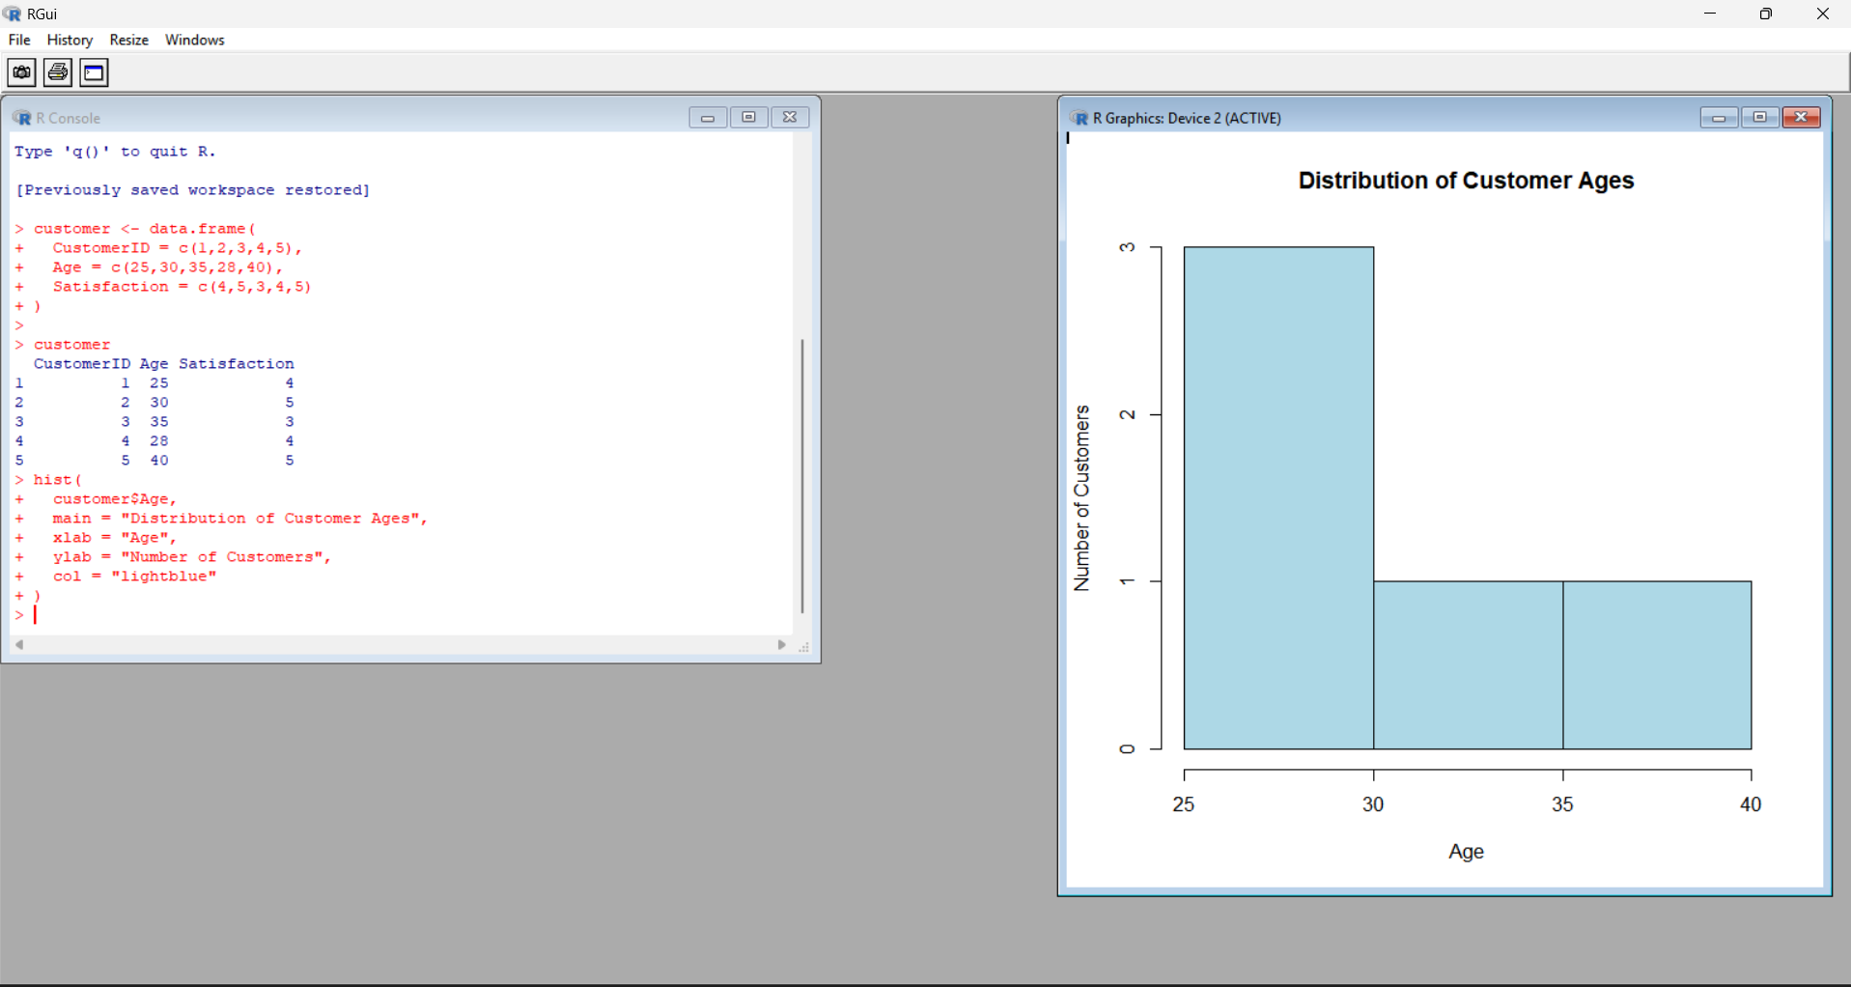

Output 1: Distribution of Customer Ages
Observation: The histogram represents the distribution of the five customer ages in the given dataset.
PROGRAM 2: Pie Chart of Satisfaction Scores
Generate a pie chart to display the overall distribution of customer satisfaction scores and include labels.
# Satisfaction scores
satisfaction <- c(4, 5, 3, 4, 5)
# Calculate frequency
score_count <- table(satisfaction)
# Pie Chart
pie(score_count,
labels = paste(names(score_count), "Score"),
main = "Customer Satisfaction Scores")
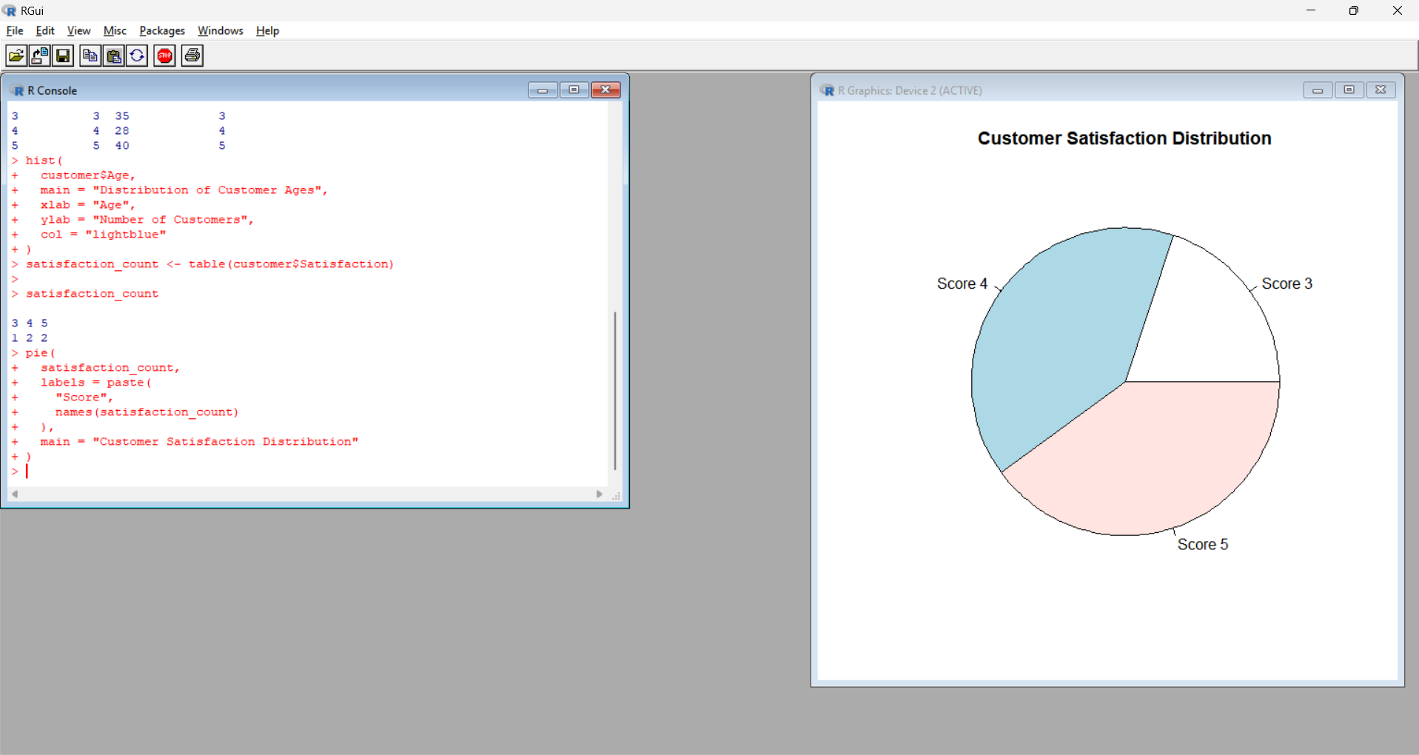
Output 2: Customer Satisfaction Scores Pie Chart
Observation: Scores 4 and 5 each occur twice, while score 3 occurs once.
PROGRAM 3: Stacked Bar Chart by Age Group
Build a stacked bar chart to visualize the distribution of customer satisfaction scores by age group.
# Dataset
age <- c(25, 30, 35, 28, 40)
satisfaction <- c(4, 5, 3, 4, 5)
# Create age groups
age_group <- cut(age,
breaks = c(20, 29, 39, 49),
labels = c("20-29", "30-39", "40-49"))
# Create table
data <- table(age_group, satisfaction)
# Stacked Bar Chart
barplot(data,
beside = FALSE,
main = "Satisfaction Scores by Age Group",
xlab = "Age Group",
ylab = "Number of Customers",
col = c("skyblue", "lightgreen", "orange"),
legend.text = TRUE)
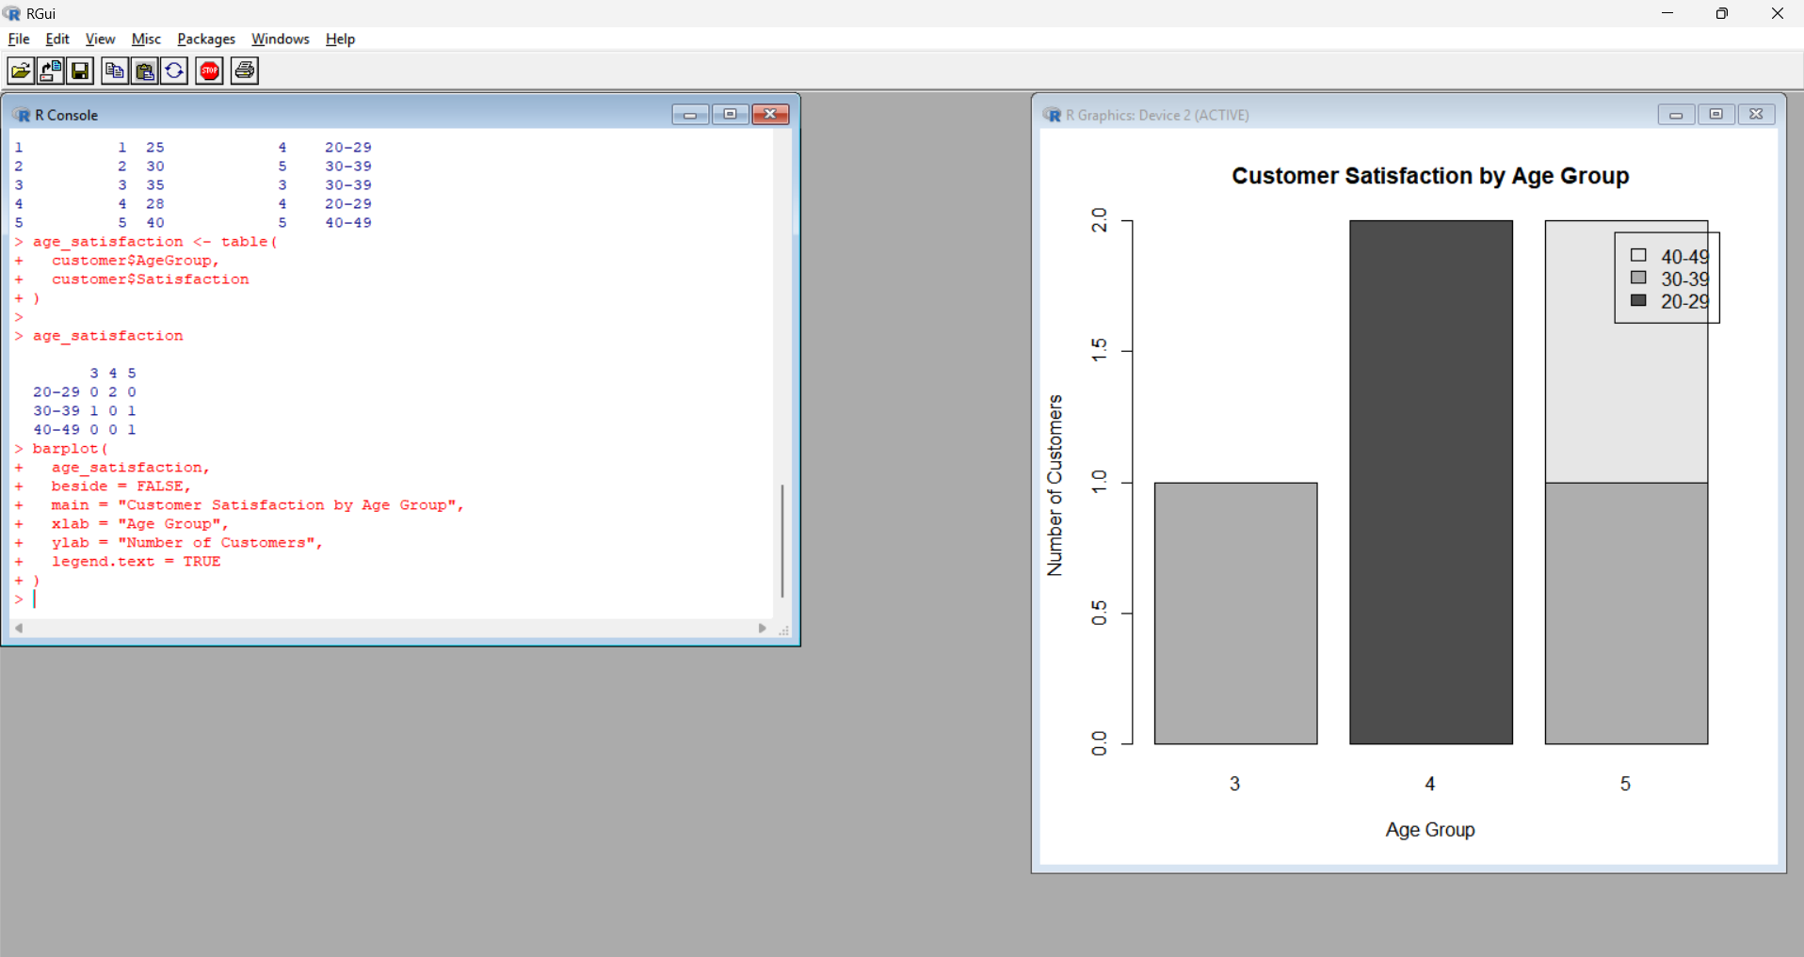
Output 3: Satisfaction Scores by Age Group
Observation: The code creates three age groups and stacks the satisfaction-score frequencies for each group.
Note: The supplied RStudio screenshot is inserted exactly as captured, including its displayed x-axis labels.
PROGRAM 4: Word Cloud of Customer Feedback
Develop a word cloud from open-ended customer feedback to identify prevalent customer sentiments.
library(wordcloud)
library(RColorBrewer)
feedback <- c(
"good service",
"excellent service",
"good experience",
"friendly staff",
"excellent service"
)
words <- unlist(strsplit(tolower(feedback), " "))
word_count <- table(words)
wordcloud(names(word_count),
freq = word_count,
min.freq = 1,
scale = c(3, 0.5),
colors = brewer.pal(8, "Dark2"),
random.order = FALSE)
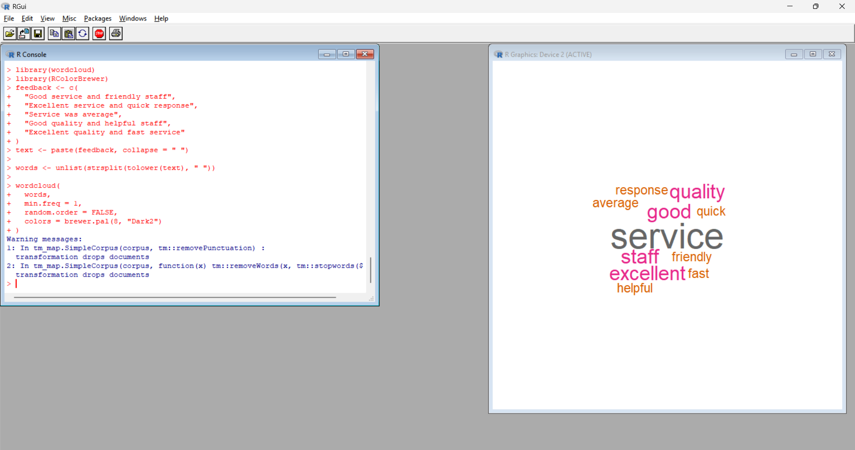
Output 4: Customer Feedback Word Cloud
Observation: The word cloud highlights frequently occurring terms in the supplied sample feedback, including service, excellent, good, friendly, and experience.

